CREATE IBM WATSON IOT PLATFORM AND DEVICE

# AIM:

To create the IBM Watson IoT platform and device.

# STEPS:

1. Firstly create an IBM cloud account with IBMid and a password.

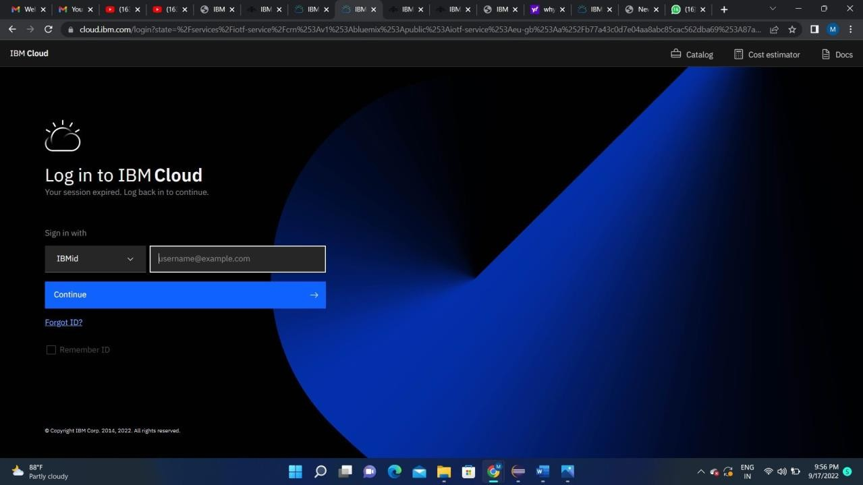

1. Home page of IBM cloud.

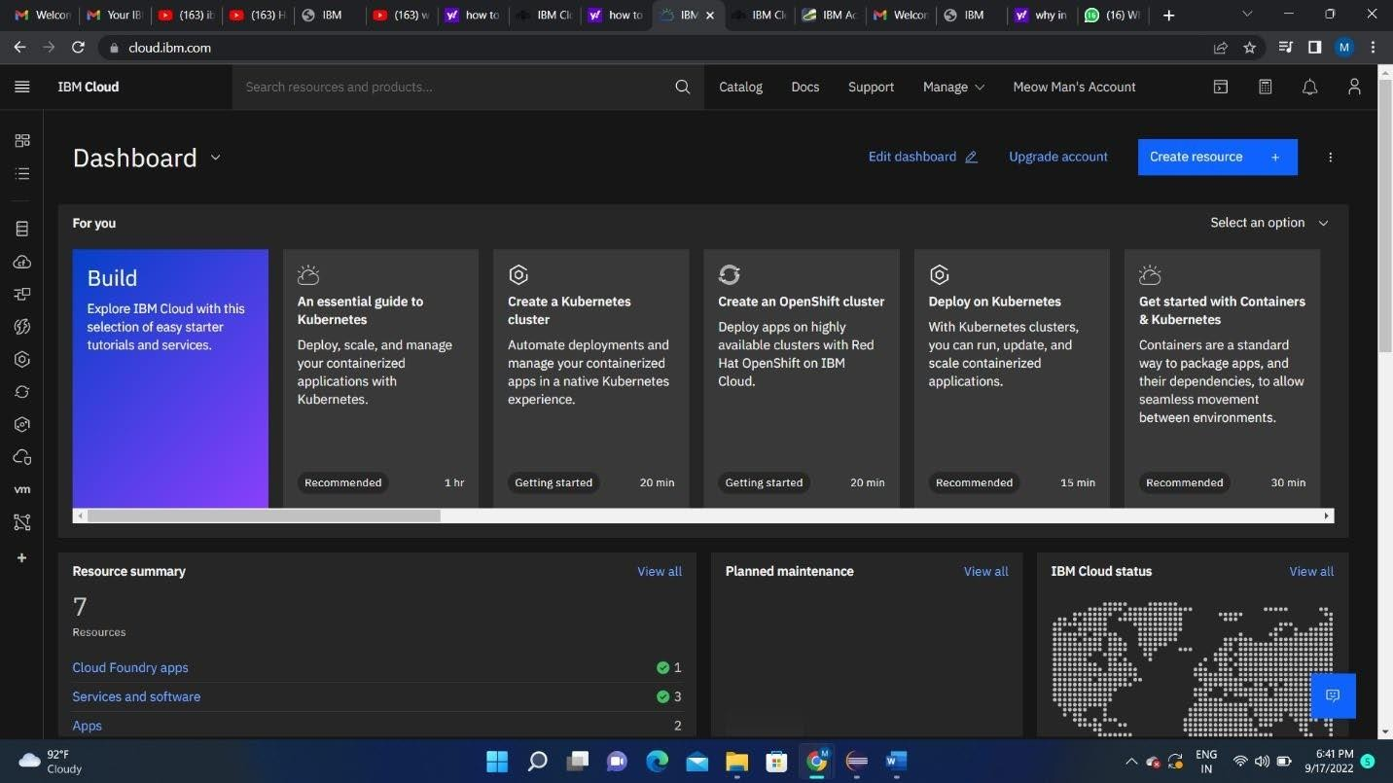

1. Internet of Things Platform Child_safety will be created, where there are different options like manage, plan, and connection.

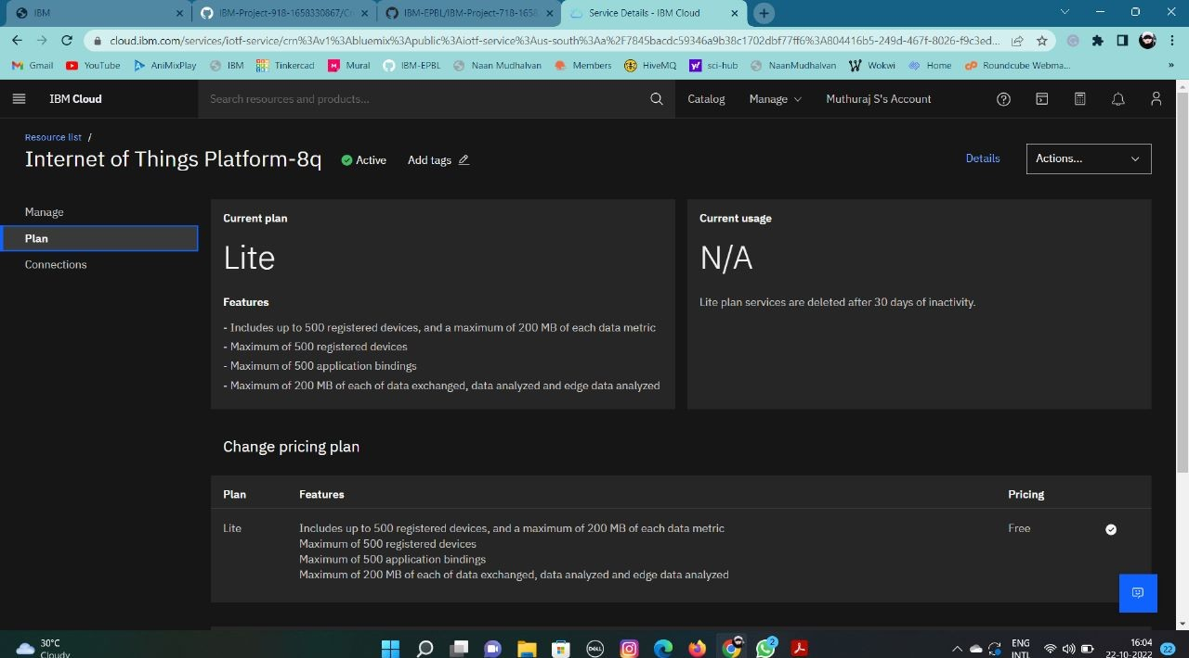

1. Clicking on the launch button in the manage tab, it will open to this.

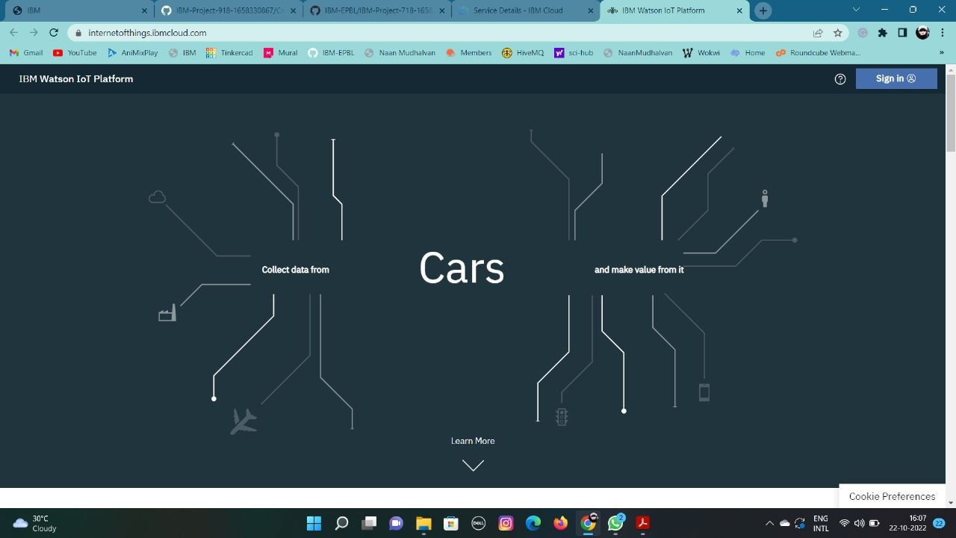

1. Enter the details to sign in to the Watson Cloud to create a device.

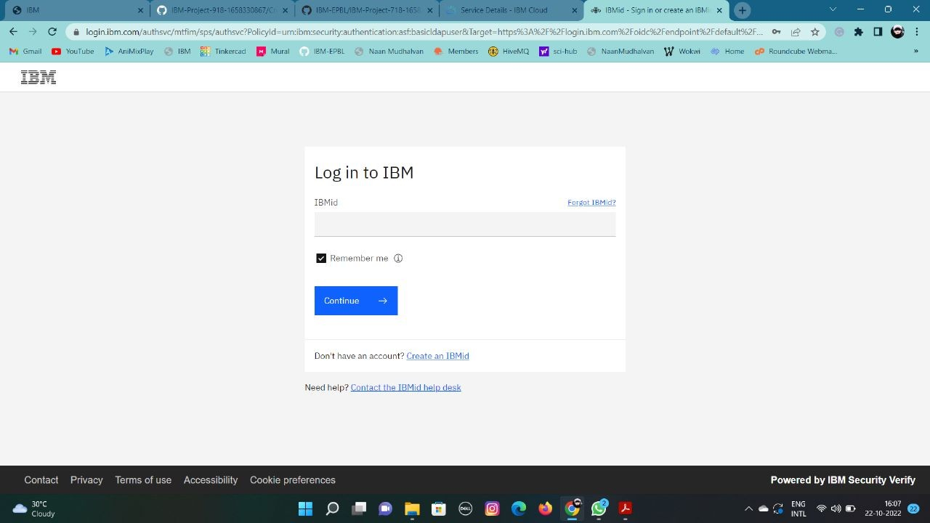

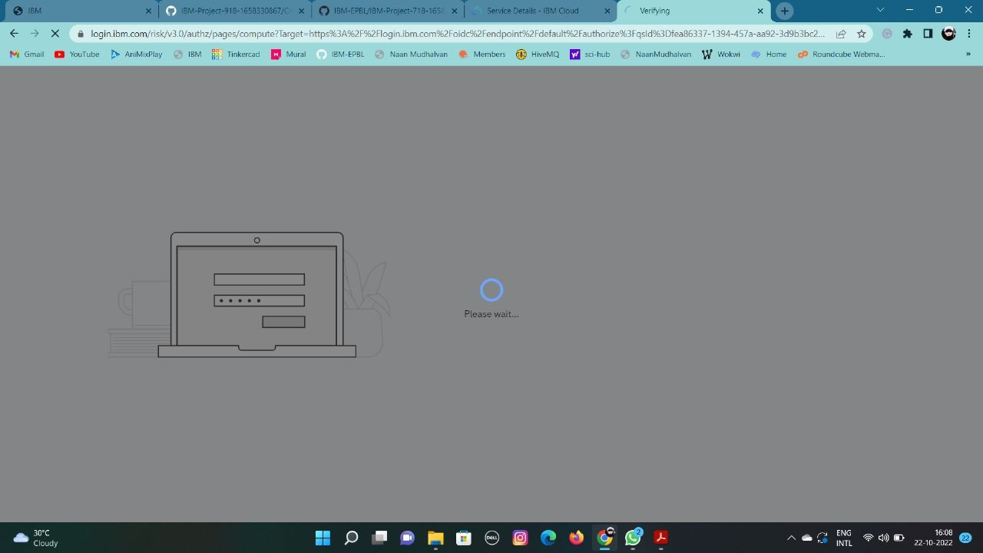

1. Once logged in the name will be displayed and it goes back to the first page.

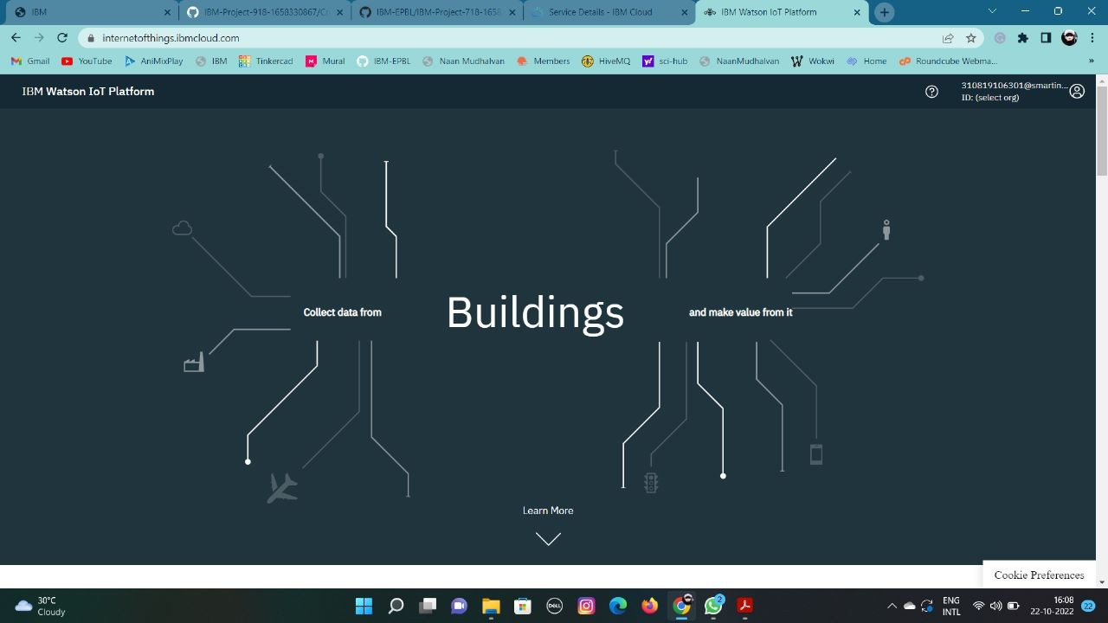

1. And again clicking on the launch button will open this tab, the device will help in the creation of the devices, the addition of devices, and the display of details of the devices.

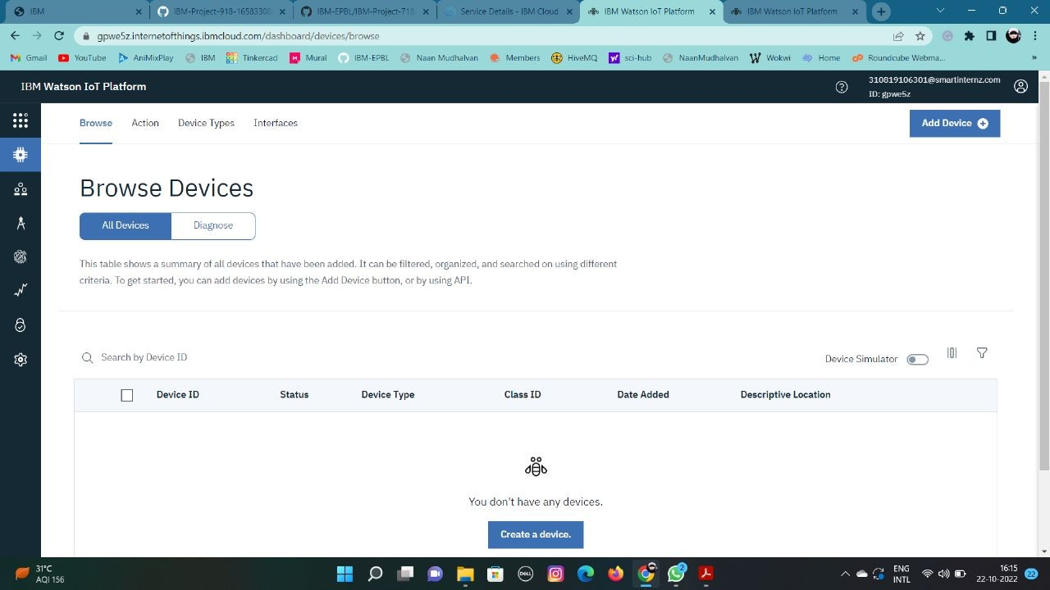

1. The setting tab is used to change the general setting if needed for the project.

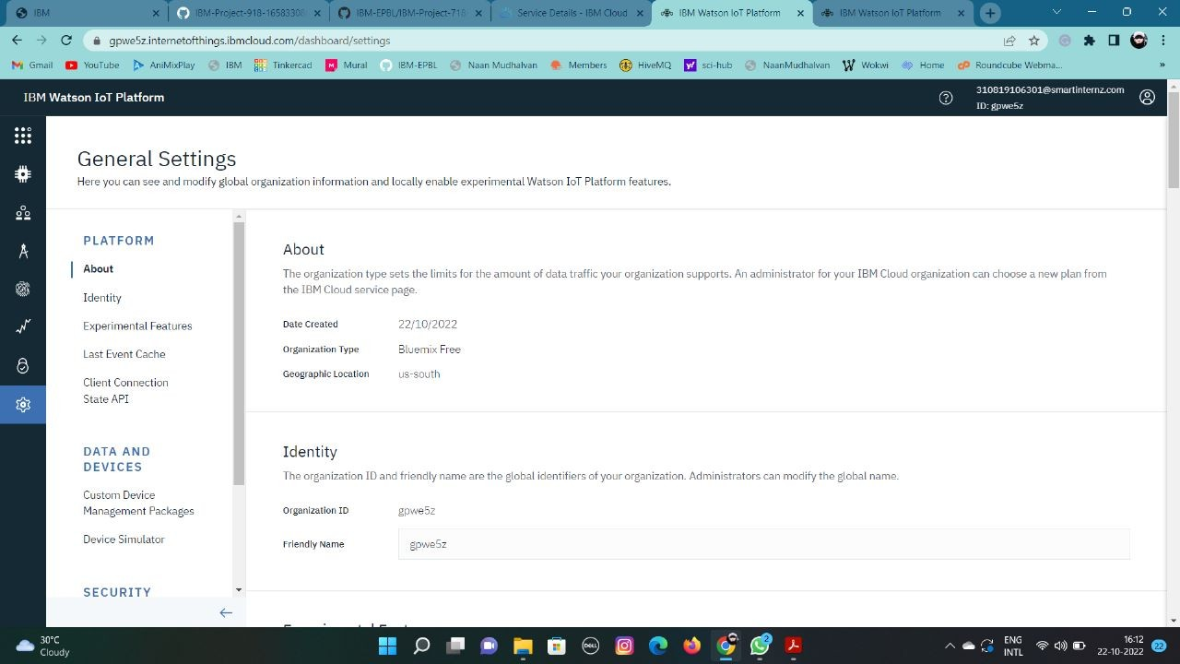

1. the security tab we can choose the type of security connection and can change according to specification.

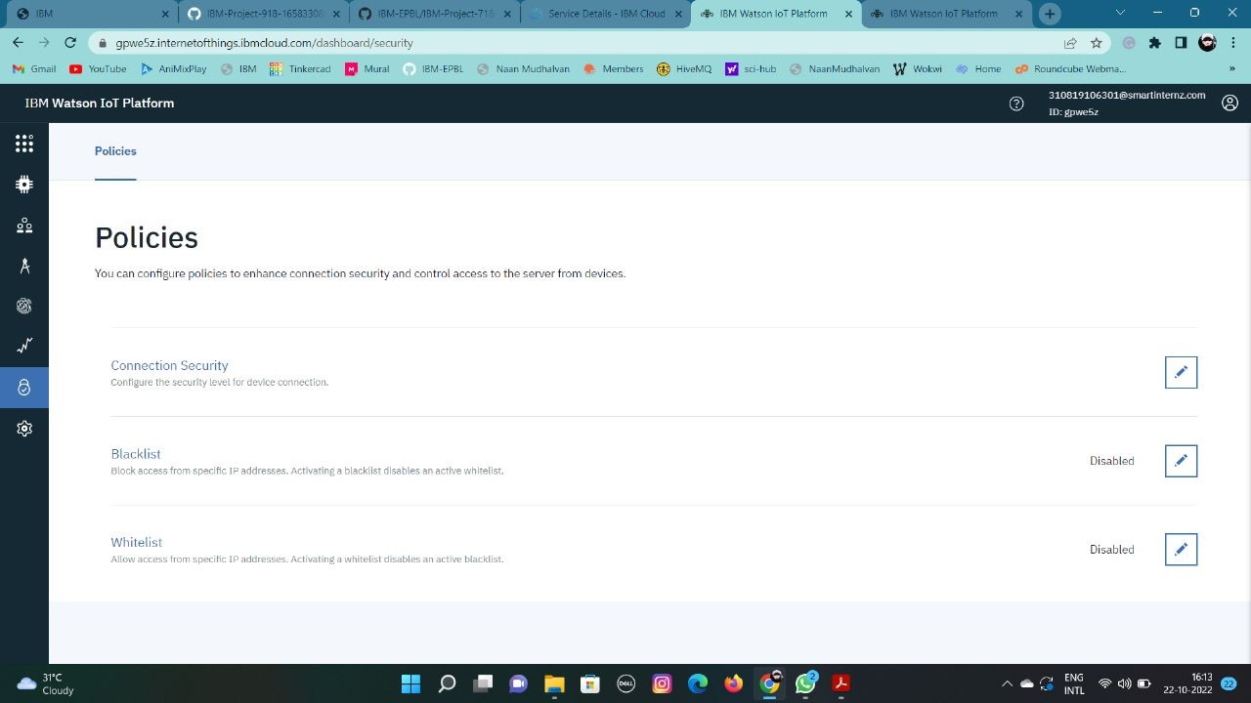

1. 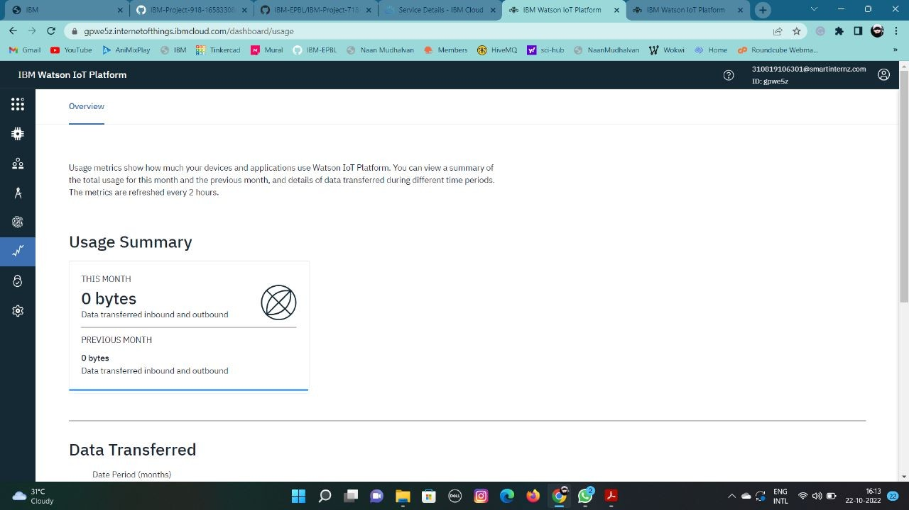Usage gives the summary of how many bytes are used between the devices and the IBM cloud.
2. The member tab is add the teams members to work in the platform.

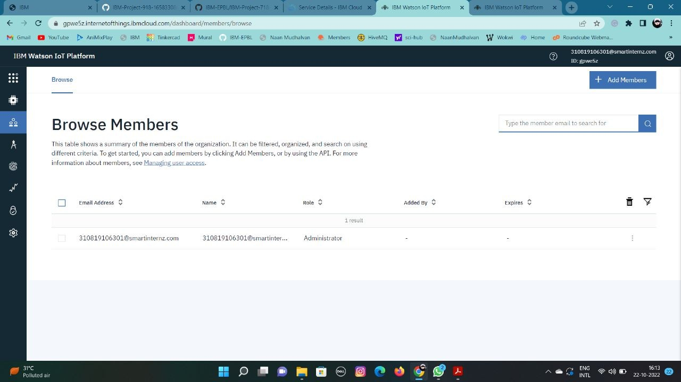

1. 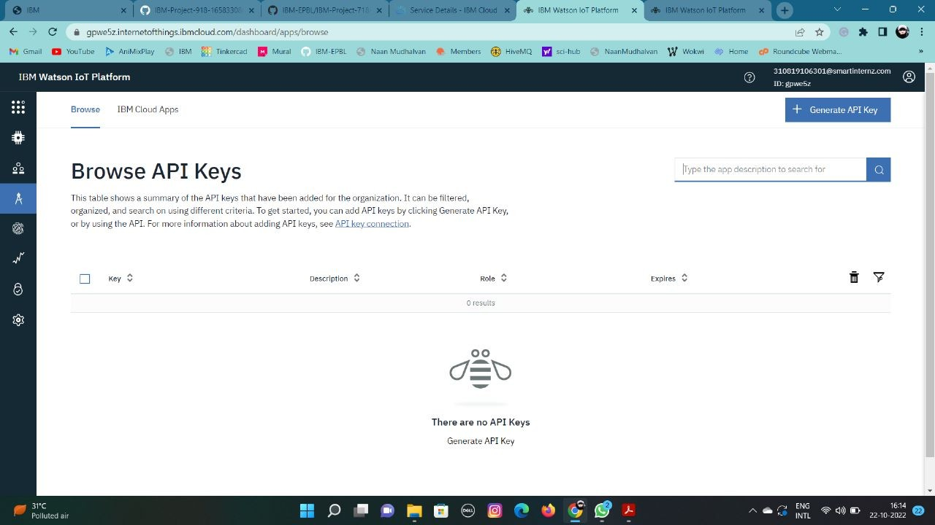This tab is used when you want to connect to some other platform and to integrate with other services.
2. Click on the device tab and click on the add device button, then give the device type and device id and click next.

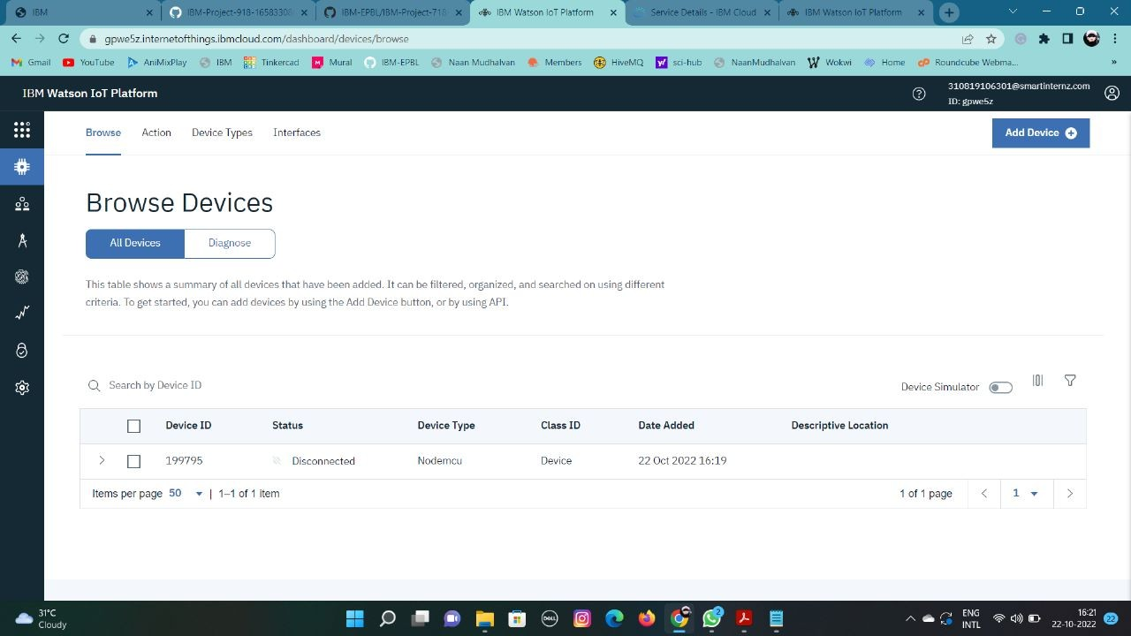

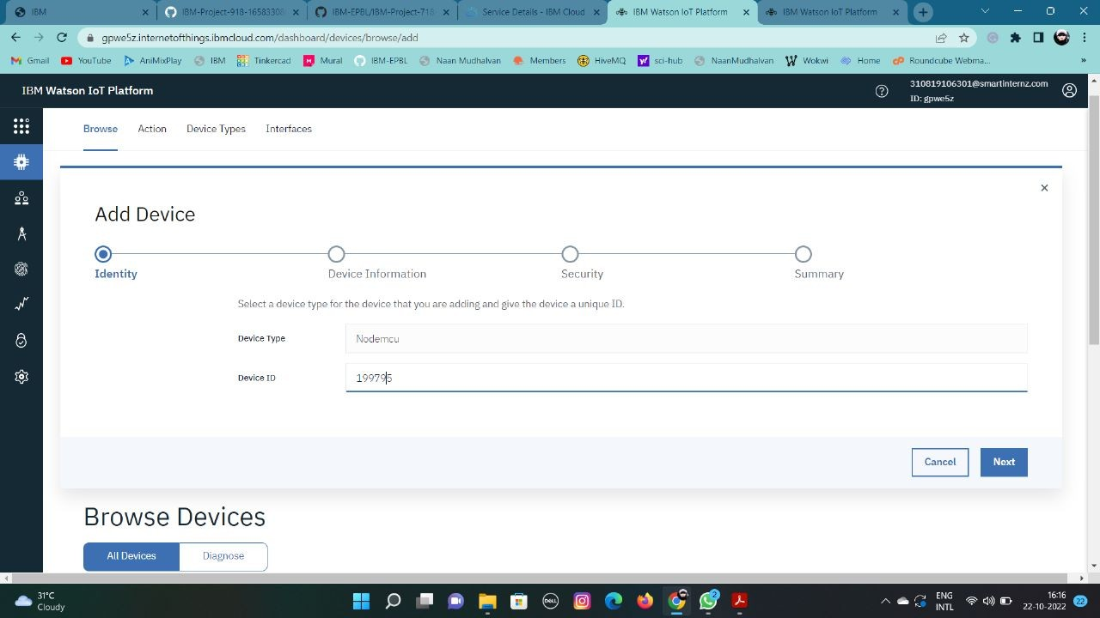

1. This page to enter extra details and of the hardware.

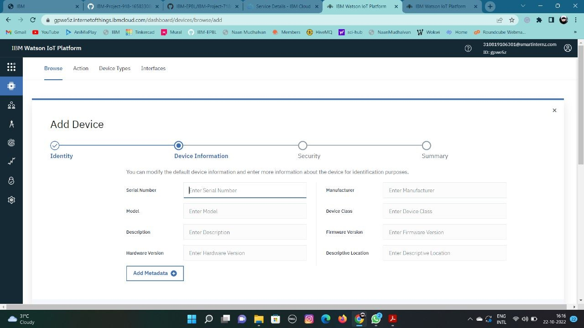

1. Clicking on next it goes to the summary of the device then click finish.

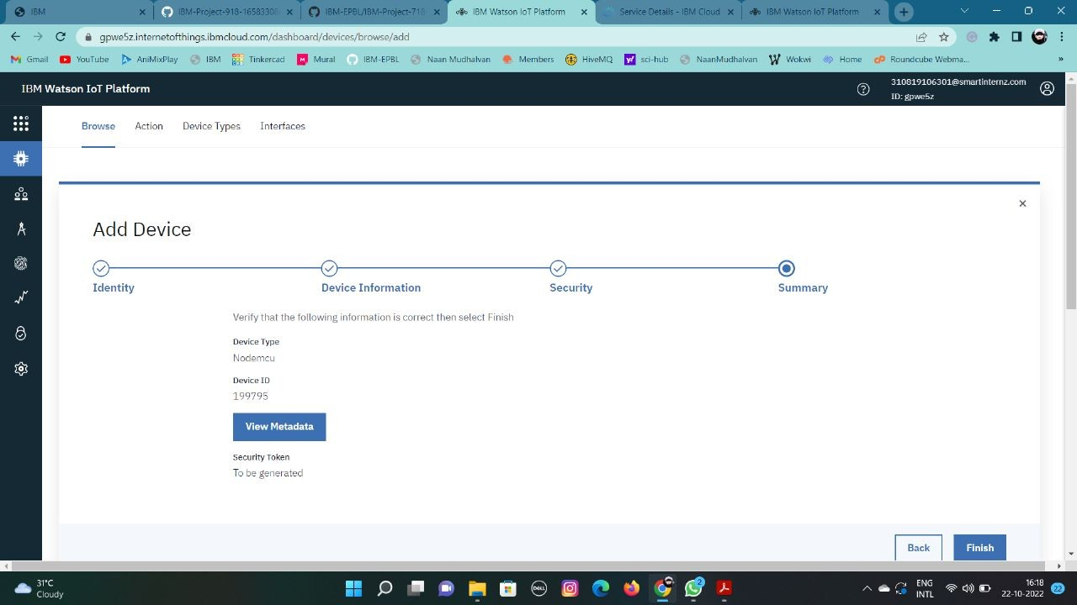

1. The device credentials will be displayed with all the details.

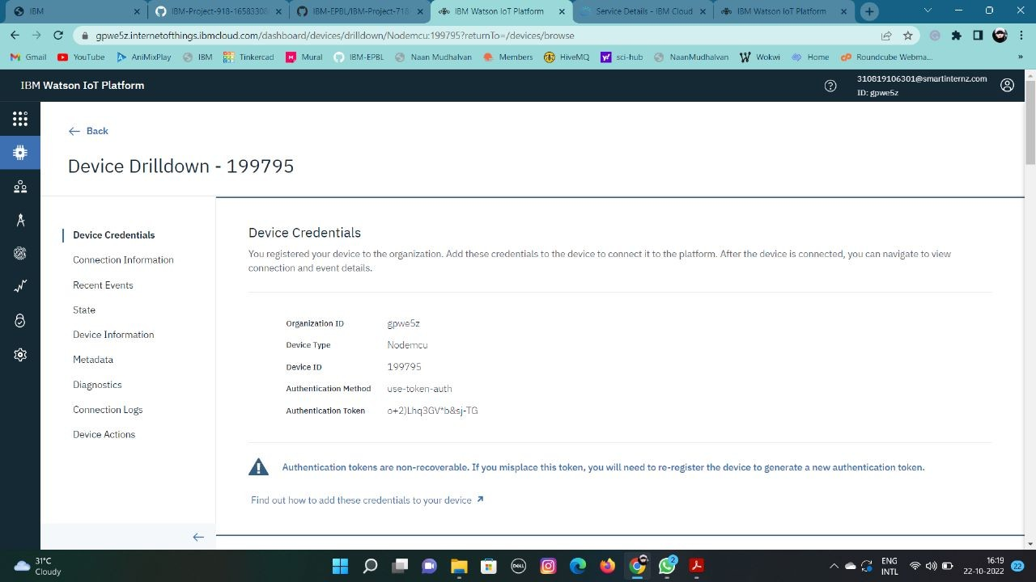

1. Clicking on the device tab we can now see the added device. Clicking on it will display the other details.



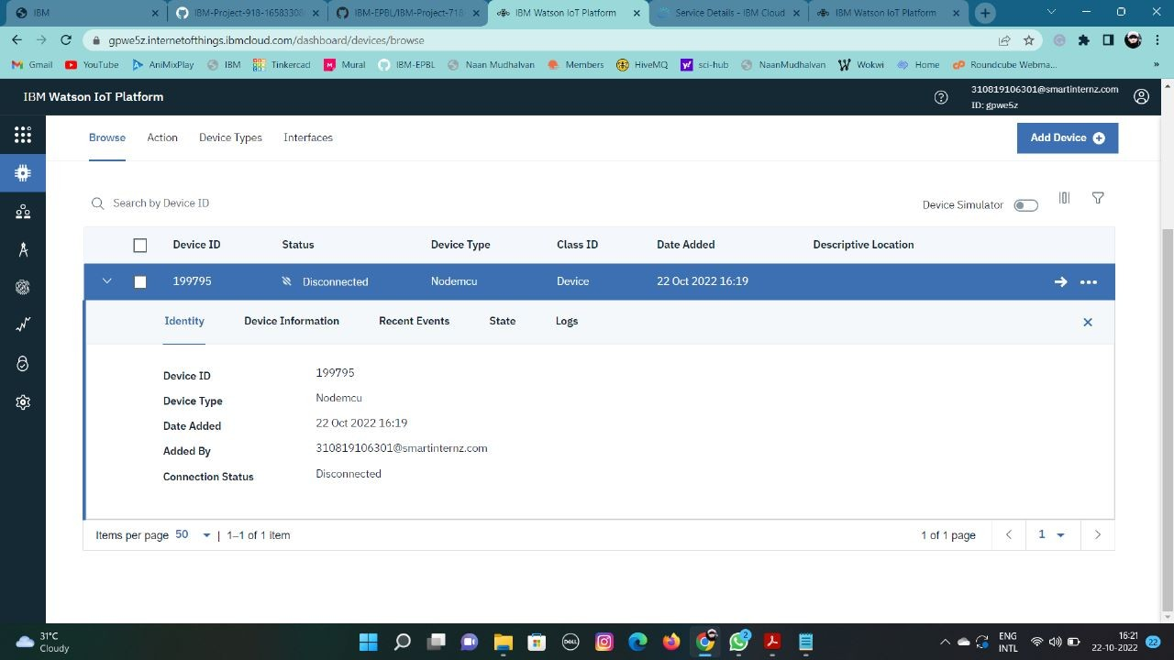

1. The Boards will display card for the project.

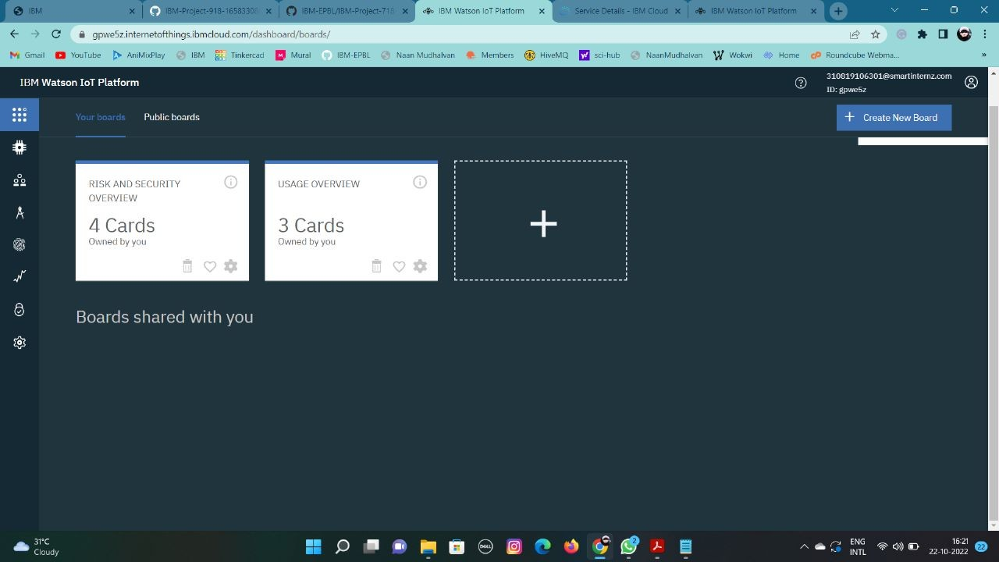

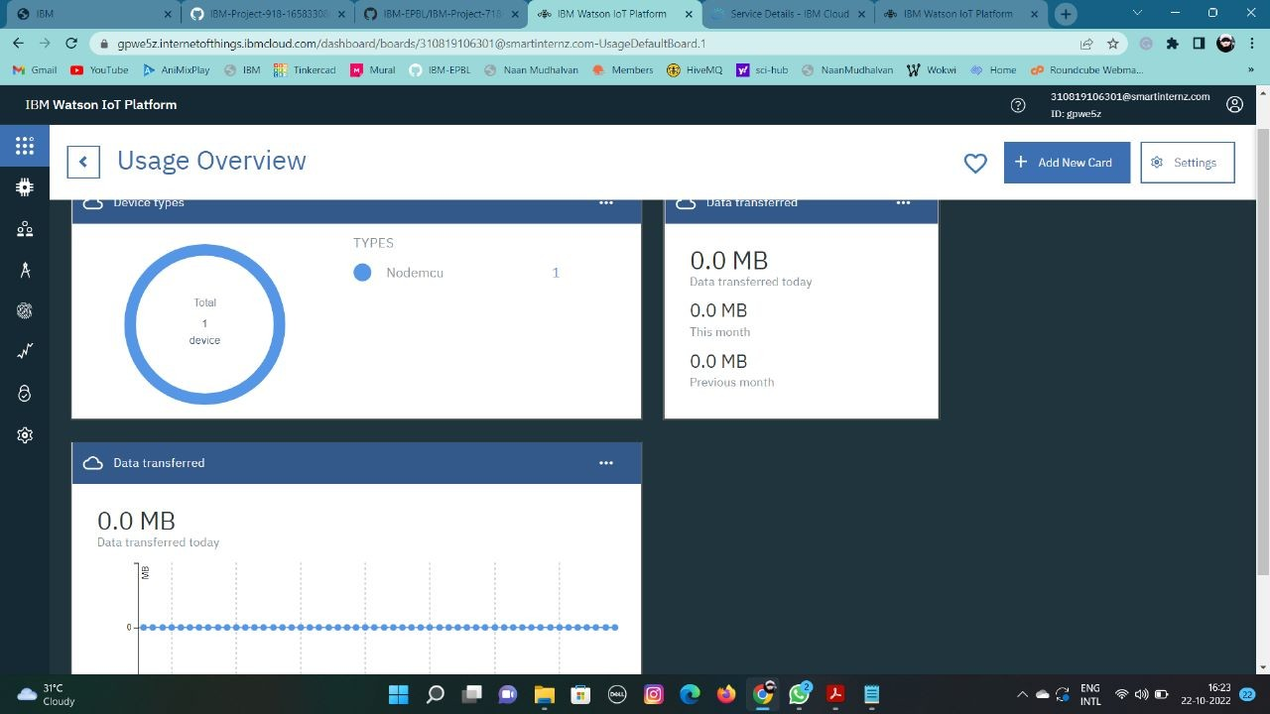

# RESULT:

An IBM Watson cloud for IoT and a device is created.